Advisory: Systematic Underestimation of Liver Stiffness due to Small Pixel Size
Resoundant has identified a systematic error in liver stiffness measurements generated using Multi-Model Direct Inversion (MMDI) software versions 3.0.x and 3.1.x when images are acquired with pixel sizes different from the validated 1.65 mm specification.
Description of the Problem:
Multi-model direct inversion (MMDI) is the algorithm used to create standard contrasts – stiffness, wave, and confidence. Stiffness of a pixel is estimated using data in a small, circular kernel. In MMDI versions 3.0.x and 3.1.x, stiffness is calculated using a fixed 11-pixel kernel. Because the kernel size is defined in pixels rather than millimeters, changes in image pixel size (caused by changes in field of view or matrix resolution) alter the effective physical size of the kernel.
As a result:
- Smaller pixel sizes (<1.65 mm) result in systematically lower (softer) stiffness values
- Larger pixel sizes (>1.65 mm) result in systematically higher (stiffer) stiffness values
This creates a measurement bias directly linked to pixel size.

For reference:
- A 420 mm FOV with 256x256 matrix produces 1.65 mm pixels (validated configuration)
- Normal variation of the FOV to optimize patient fill factor has a relatively small effect on stiffness – only a few percent change.

Affected Configurations:
This issue applies to:
- MMDI versions 3.0.x and 3.1.x
- Affected Configurations: Philips
- Unaffected Configurations: Canon, GE, Siemens, United Imaging

Between MMDI versions 3.1 and 3.2, a key change was made to this choice of kernel size:

MMDI version | Kernel size | Pixel size
3.0.x, 3.1.x | 11 pixels | 1.65mm
3.2.x | 18 mm | Any*

Recommendations:
- Optimal protocol: Keep FOV and resolution consistent. 420mm FOV and 256x256 resolutions are recommended.
- Update to MMDI v3.2 or later. Note that MMDI is an integral part of the MRE application and can likely only be updated with an update to the scanner software.

Clinical Impact:
The measurement bias may result in systematic underestimation of liver stiffness when small pixel sizes are used.

In some cases, the degree of underestimation is sufficient to:
- Potentially classify a patient one fibrosis stage lower than their actual stage
- Influence clinical decision-making and treatment planning

The following shows a percentage change as a function of stiffness for 390 exams. There are a significant number of cases that are sufficiently low estimates that they would likely have been diagnosed as a full fibrosis stage lower than actual, which would negatively affect their treatment plan.

The following images show the colorized representation of the default settings, Recommended settings, and default settings reconstructed with MMDI 3.2. This illustrates that the issue is difficult to detect, as all images appear high quality.
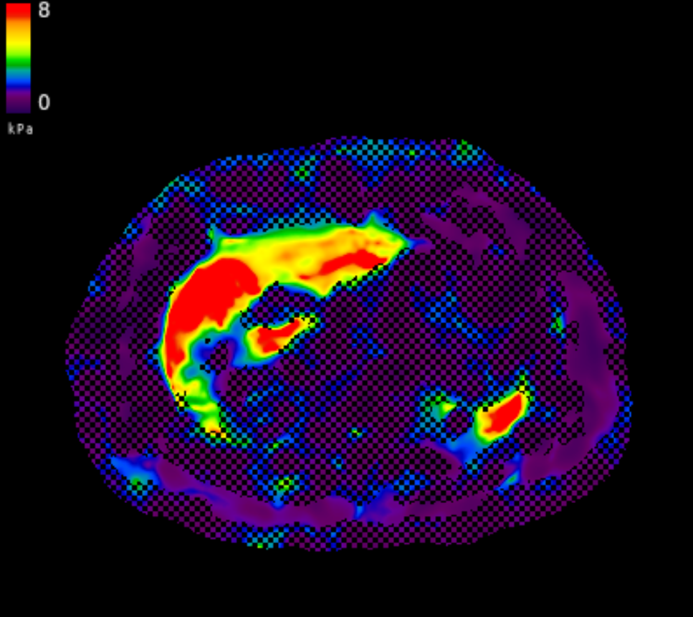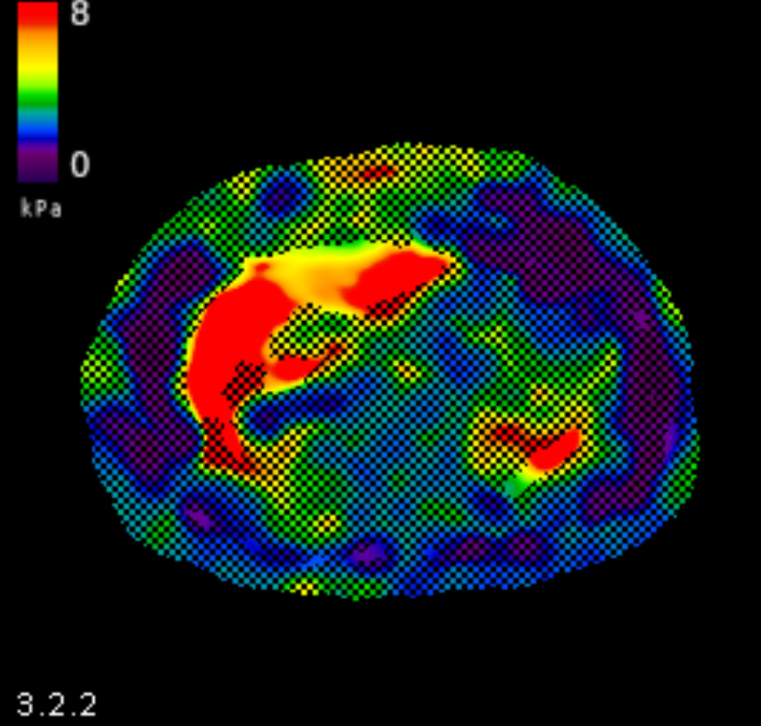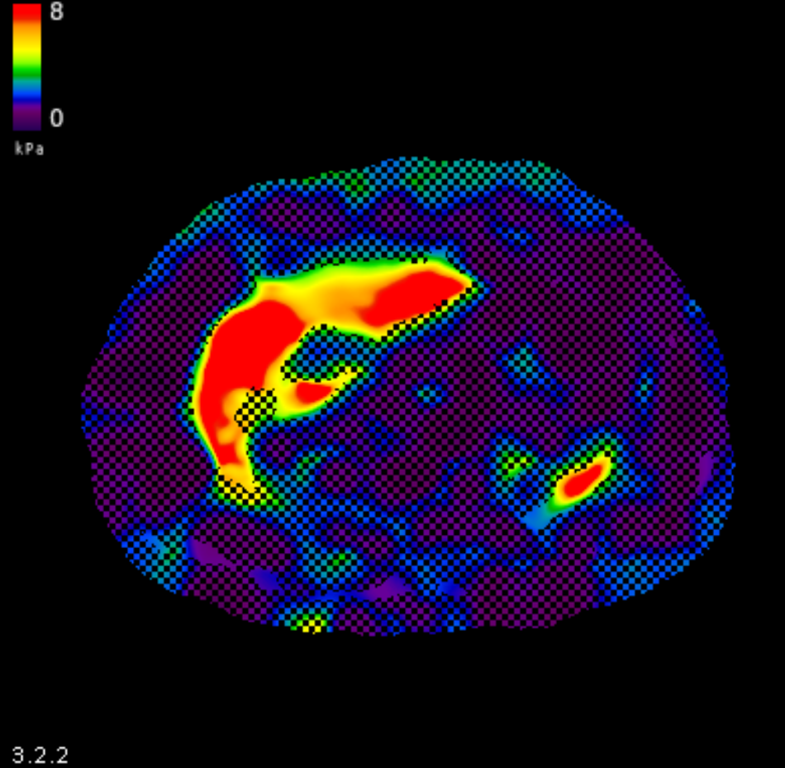
Left: Elastogram obtained with 1.17mm pixels (default size). Stiffness measurements in liver are biased toward softer values.
Middle: Result obtained with correct pixel size (1.65mm pixel). This image was created by down-sampling and processing the data that produced the image on the left.
Right: Result with smaller than recommended pixel size, reconstructred with MMDI 3.2. Liver stiffness is similar to that obtained with recommended pixel size.
Detectability:
MRE stiffness images created from small or large pixels will look similar to optimal values.
- The resulting elastogram images appear visually normal and high quality
- The error is not visually detectable from the image appearance
- The issue can only be identified by reviewing:
  - Pixel size (DICOM tag (0028,0030), “Pixel Spacing”)
  - MMDI software version (version displayed on the images)

Actions Required by MRE Users
Customers using MMDI 3.0.x or 3.1.x must:
- Review MRE protocol parameters - Validated protocol parameters available at resoundant.com/qiba
- Adjust acquisition settings to ensure a pixel size of 1.65 mm
- Confirm pixel size in DICOM tag (0028,0030)

Summary of risk:
When smaller-than-recommended pixel sizes are used with MMDI 3.0.x or 3.1.x:
- Liver stiffness values may be systematically underestimated
- This may lead to underestimation of fibrosis stage
- The error is not visually apparent
- The issue is fully corrected by protocol adjustment or software update

